Stolen Dogs
!!!Please Help!!!
$$1500 REWARD$$
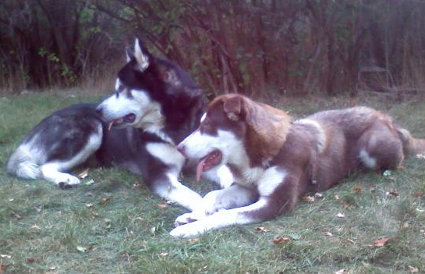
Two Giant Alaskan Malamutes stolen from Ukiah, CA on 6/29. Suspects: two males, 18-25, driving an older RV and a 2000s black Nissan Frontier. Sightings: Santa Rosa (positive) and Santa Cruz (possibly). Could be anywhere in CA or beyond by now. Large reward, no questions asked, for the return of my dogs. My black&white male is 160lbs and the red/brown&white female is 120lbs; they are people-friendly, but unsafe with small animals. I am heartbroken, please help! Call Dan with ANY info: (605) 645-6248

